./



Version Number:

Team Members :

Team No:

Module: Model Based System Engineering

|  |  |  |  |  |  |
| --- | --- | --- | --- | --- | --- |
| **Ver.Rel. No.** | **Release Date** | **Prepared. By** | **Reviewed By** | **Approved By** | **Remarks/Revision Details** |
|  |  |  |  |  |  |
|  |  |  |  |  |  |
|  |  |  |  |  |  |
|  |  |  |  |  |  |
|  |  |  |  |  |  |

**Document History**

Table of Contents

1.0 INTRODUCTION :……………………………………………………………………..3

2.0 REQUIREMENTS………………………………………………………………………3

2.1 SWOT ANALYSIS…………………………………………………………………..3

2.2 COMPONENTS USED IN FIRE ALARM………………………………………..4

2.3 4W'S AND 1H……………………………………………………………………….5

2.4 TABLE OF REQUIREMENTS.........................................................................5

3.0 ARCHITECTURE………………………………………………………………………6

4.0 SIMULATION…………………………………………………………………………..8

**5.0 OTHERS**…………………………………………………………………………………**9**

# ULTRASONIC DETECTING SENSOR

# 1.0 Introduction:

Ultrasonic detection is most commonly used in industrial applications to detect hidden tracks, discontinuities in metals, composites, plastics, ceramics, and for water level detection. For this purpose, the laws of physics which are indicating the propagation of sound waves through solid materials have been used since ultrasonic sensors using sound instead of light for detection.

**2.0 Requirements:**

**2.1 SWOT ANALYSIS:**

**2.2 Components used in ultrasonic Detecting sensor:**

Ultrasonic sensor HC SR04

Lcd(16*2) //HD4470-10

Arduino Uno

Potentiometer

Power supply

Ground

**Ultrasonic sensor HC SR04:**

* The ultrasonic sensor works on the principle of SONAR and RADAR system which is used to determine the distance to an object.
* An ultrasonic sensor generates the highfrequency sound (ultrasound) waves. When this ultrasound hits the object,it reflects as echo which is sensed by the receiver.
* HC-SR-04 module has an ultrasonic transmitter, receiver, and control circuit on a single board.

**Power supply:**

It is used to give the power supply to the circuit.

**Lcd Display(16*2):**

* The term LCD stands for liquid crystal display.
* It is one kind of electronic display module used in an extensive range of applications like various circuits and devices like mobile phones, calculators, computers, TV sets, etc.
* These displays are mainly preferred for multi-segment light-emitting diodes and seven segment display.

.

**Arduino Uno:**

* The Arduino Uno is an open-source microcontroller board based on the Microchip ATmega328P microcontroller and developed by Arduino.
* The board is equipped with sets of digital and analog input/output (I/O) pins that may be interfaced to various expansion boards (shields) and other circuits

**2.3 4WS & 1H**

**Where:**

Ultrasonic sensor is used in **oil, chemical, milk or water tanks** for level measurements or for liquid level control.

This sensor is used in thru beam detection for high speed counting.

This sensor is used in robotic industry for robot sensing.

**When:**

The sensor is used in when the liquid level measuremens are high.

**What:**

An ultrasonic sensor is an **instrument that measures the distance to an object using ultrasonic sound waves**.

An ultrasonic sensor uses a transducer to send and receive ultrasonic pulses that relay back information about an object’s proximity.

High-frequency sound waves reflect from boundaries to produce distinct echo patterns

**Why:**

Ultrasonic sensor is used in **oil, chemical, milk or water tanks** for level measurements or for liquid level control .

**How:**

It is shown in below figure how it connected and used.

**2.4 TABLE OF REQUIREMENTS:**

**High level Requirements:**

|  |  |
| --- | --- |
| ID | Description |
| HRL-1 | It shell send echo to find object |
| HRL-2 | It shell able to detect Moving object |
| HRL-3 | Moving object signal will displayed on a display unit |

**Low level requirements:**

|  |  |
| --- | --- |
| Id | Description |
| LLR-1 | It shell find the exact location of an Target |
| LLR-2 | It shell find distance of an object |
| LLR-3 | It shell find speed of an object |
| LLR-4 | It shell display distance of an object |

# Advantages:

# The ultrasonic sensor has high sensitivity, high frequency and high penetrating power therefore it can easilydetect the external or deep objects.

# The use of ultrasonic sensor makes this system more accurate and precise than other methods.

* This system is easy to use, not dangerous during operation for nearby objects, person, equipment or material.
* Radar systems have a number of defense as well as civil applications.

# Applications:

* It is used in machines like Automotive parking sensor obstacle warning systems,industrial distance measurements, terrain monitoring robots.
* Radar speed meters are used by the traffic police for enforcing speed limit.
* Marine radars used to locate the landmarks and other ships.
* Air traffic control uses radars to track aircraft on the ground, in the air and to guide planes for smooth landings.

**3.0 ARCHITECTURE:**

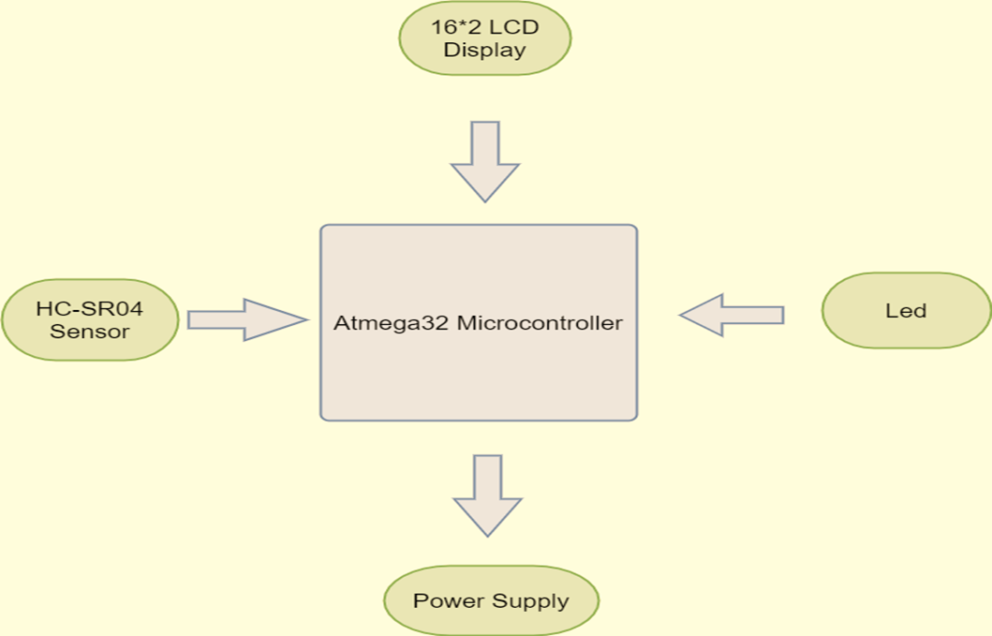

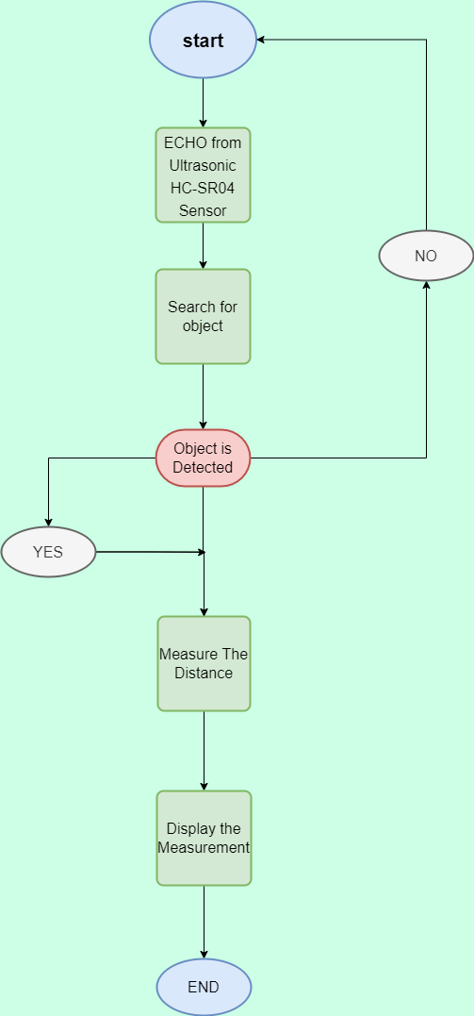

**4.0 SIMULATION:**

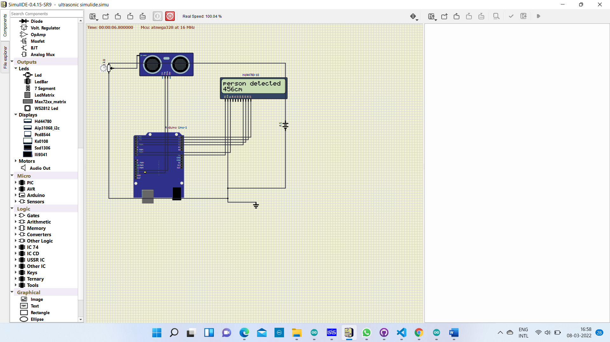

**5.0 OTHERS:**

### 8 Features of the Ultrasonic Distance Sensor:

* Supply voltage: 5V (DC).
* Supply current: 15mA.
* Modulation frequency: 40Hz.
* Output: 0 – 5V (Output high when obstacle detected in range).
* Beam Angle: Max 15 degrees.
* Distance: 2cm – 400cm.
* Accuracy: 0.3cm.
* Communication: Positive TTL pulse.

### Specifications:

* Power supply: 5V DC
* Quiescent current: <15mA
* Effectual angle: <15°
* Ranging distance: 2cm – 350 cm
* Resolution: 0.3 cm
* Output cycle: 50ms